POWER BI – 13TH September

**Start lab and launch web desktop**

**Start POWER BI**

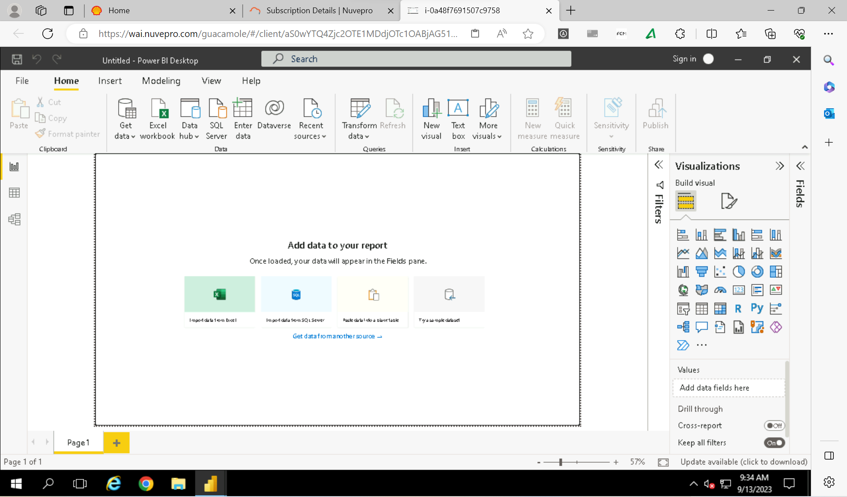

Power query

Power view

Power map

Power pivot

